Problem Statement 1:

Dataset: Thanksgiving.csv
Filename: Save the file as Tha

ksgiving.pbix
n

Q1. Discover regional and income-based patterns in what Americans eat for Thanksgiving.

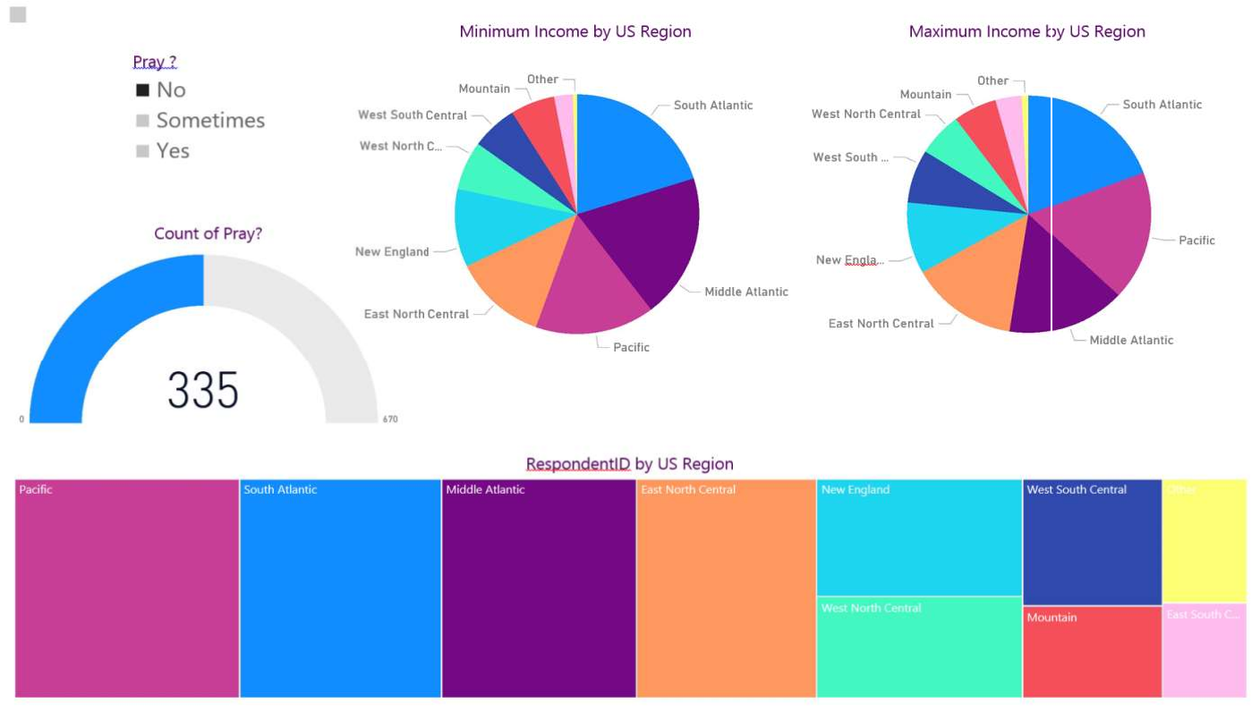

Q2.Compare income between
people who tend to eat homemade cranberry sauce for
Thanksgiving vs people who eat canned cranberry sauce?

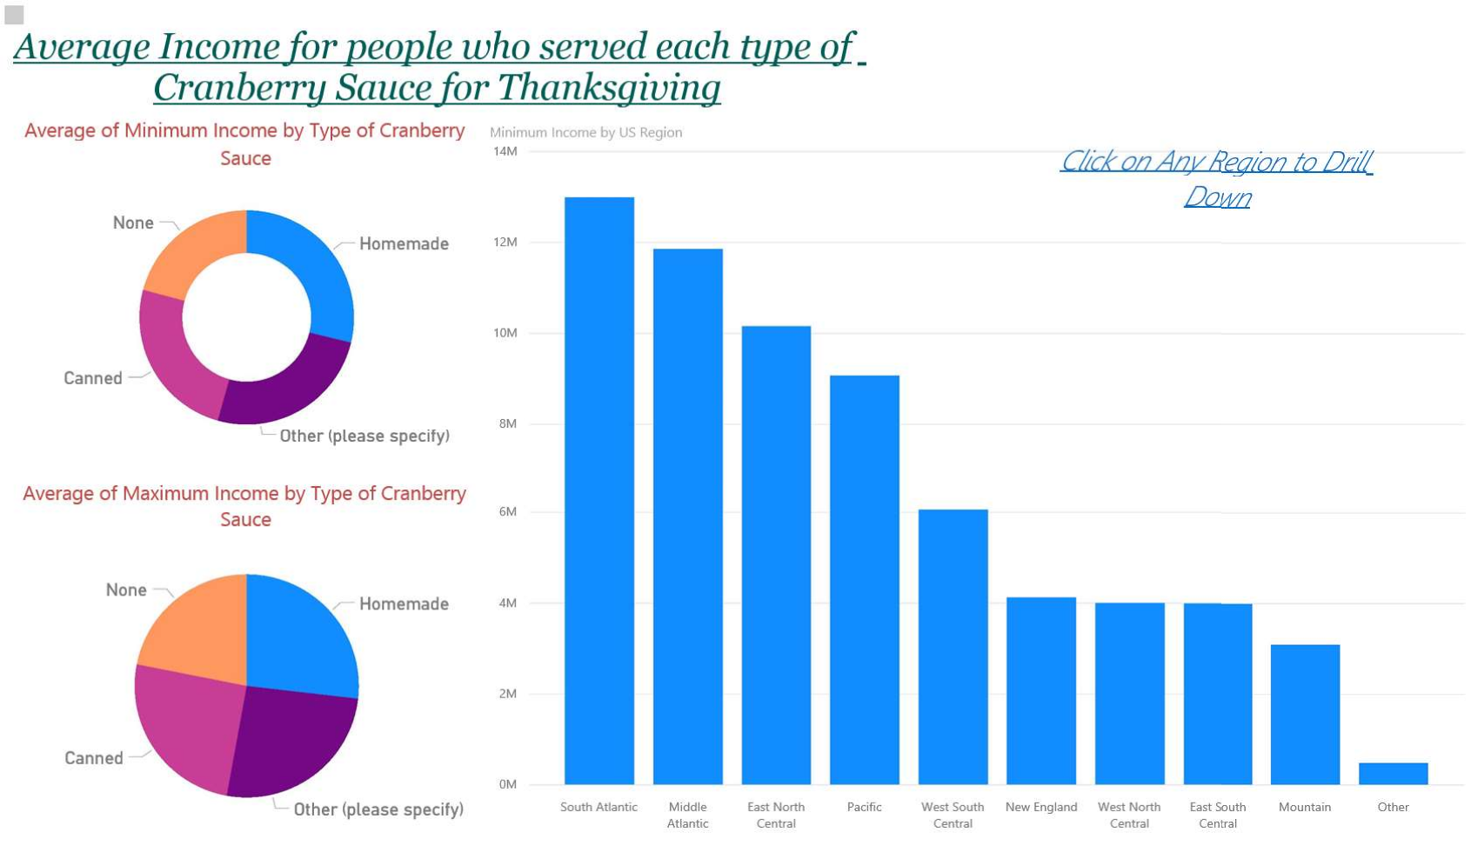
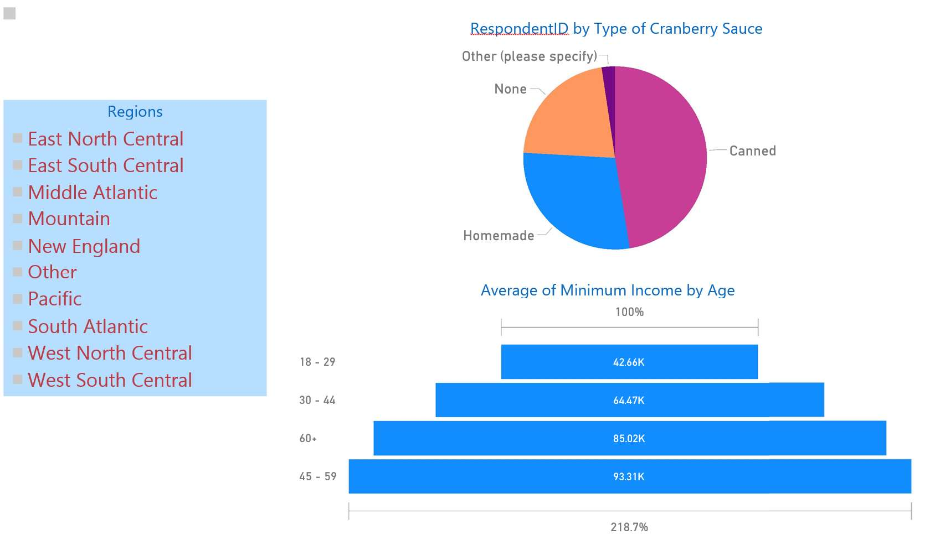Q3. Find the average income
m
Thanksgiving (Canned, Home

Q4. Find the number of peopl
for people who served each type of cranberry sauce for ade, None, etc).

who live in each area type (Rural, Suburban, etc), who eat
e
different kinds of main dishes for Thanksgiving.

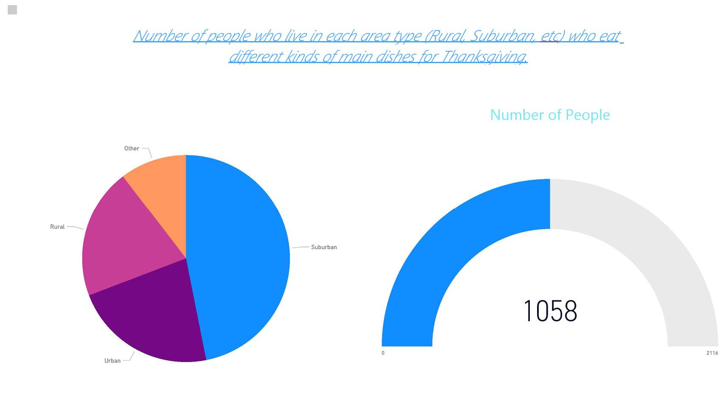
Problem Statement 2:
Filename: Save the file as FIFA.pbix

Let’s make some visualization with the Report tab based on the data in model we’ve built so far.
Goals Scored Column Chart
From the Fields section under TeamGoals, drag and drop teams into the main pane, then drag and drop Goals Scored on it.

Map
Double click on the map from visualization section. Then from TeamPasses, Drag and drop Teams into the Location section of the map setting. Bring Passes Completed into the values section. Let’s change the color, and color saturate it by number of matches each team played.

Gauge
Now let’s create a gauge for goals scored. Set the value as Goals Scored. Minimum value as Min of Goals Scored, Maximum value as Max of Goals scored, and the Target as Average of Goals Scored.

Clustered Column and Line Chart
As the last visualization item in this report I would like to show a column chart combined with line chart. The column values show Completed Clearance from TeamDefendings, and the line value shows number of Saves.

Hint:
Number of goals scored by each team listed in this URL:
http://www.fifa.com/worldcup/archive/brazil2014/statistics/teams/goal-scored.html

The second data set is passed by teams which we get from this URL:
http://www.fifa.com/worldcup/archive/brazil2014/statistics/teams/passes.htm

Add another data set to this analysis which is Teams Defending result set. http://www.fifa.com/worldcup/archive/brazil2014/statistics/teams/defending.html

Steps to get this data set into Power BI are:
• Open Power BI Desktop
• Choose Get Data
• In Get Data Window, under Other, click on Web

Problem Statement 3:
Name: Save your file as IPL.pbix
Perform the following:
1. Plot the points table. Also plot on the same chart that how many league matches have been played by each team.
2. Plot top 10 batsmen who scored most.
3. Plot top 10 batsmen strike rate. Also show how many runs they have scored.
4. Plot top 10 wicket takers.
5. Plot top 10 bowling average.
6. Plot total runs scored team wise.
7. Plot total wickets team wise.
8. Plot how much money spent by each team.
9. Show the purple cap player name.
10. Show the orange cap player name.

